Study on Local Fiscal Policies and Practices Addressing Poverty Issues of Local Government Units in Lanao del Norte

Abstract

Generally, this inquiry attempted to investigate the Local Policies and Practices addressing poverty concerns and issues of local government Units in Lanao del Norte. Specifically. It sought to answer the following research questions.
- What were the local fiscal polices and projects implemented that can address poverty concerns of LGUs in Lanao del Norte?
2. What was the appropriation for programs and projects addressing poverty
issues of LGUs?
3. What were the sources of fund for programs and projects that respond to
poverty problems?
4. What were the practices employed by the LGUs in alleviating poverty?
5. What were the hindrances in fiscal policy formulation of LGUs of Lanao
del Norte that has effect in addressing poverty?
6. What was the appropriation and utilization of the Social Welfare and
Development Office for programs and services based on their plan?
7. What were the areas for the provision of Technical Assistance and
Resource Augmentation (TARA) in relation to Social Welfare and
Development and budget plan preparation for poverty issues and
concerns?

Moreover, using Salamon and Wamsley’s evaluation of fiscal policy, the study endeavored to assess the fiscal policies and practices addressing poverty with emphasis on its three components, namely: policy timing, policy character or substance and policy administration.

The study was a qualitative research. It utilized documentary reviews and focus group discussions (FGD) as tools in gathering data. The focus group discussions were conducted in all LGUs of Lanao del Norte. Participants for the focus group discussions were the following: a) Municipal Planning and Development Officer (MPDO), b) Sanggunian Bayan (SB) councilor for social services, c) Municipal Budget Officer, d) Municipal Accountant, e) Municipal Treasurer and the f) Municipal Social Welfare and Development Officer (MSWDO).

Findings from this study reveal that all LGUs in Lanao del Norte do not have existing fiscal policies to address their city/municipality’s poverty concerns. However, LGUs were still able to implement programs and projects for poverty; they often provide a fund counterpart to special projects, as specified in the contract of agreement, and conceptualize projects on their own by having proposals approved from time to time. Funds for these projects, both LGU-conceptualized and special projects, are financed by the 20% Municipal Development Fund.

Findings also showed that the LGU of Linamon had the highest allocation for Maintenance and Other Operating Expenses (MOOE) utilizing more than 50% of the total SWD appropriation. The municipality of Baroy, meanwhile, had the lowest MOOE amounting to only P5,125 or 0.85% in the year 2008. In fact, for eight (8) consecutive years now, Baroy only has an average MOOE of about P11,216.75. In all LGUs, moreover, MSWDOs are given less priority in addressing SWD concerns as reflected in their meager MOOE budgets.

In addition, all LGUs of Lanao del Norte expressed a high demand to have their legislators trained in the formulation of fiscal policies addressing poverty for their constituents. This is very important because the absence of local policies slows down the pace of development of LGUs in the province. Most of the projects implemented were not sustained, for instance, with no local administrative document to compel LGUs to sustain its projects and for beneficiaries to adhere to the projects’ terms and conditions.

I. Introduction

There are about 77 million Filipinos suffering from poverty today and this number is growing by 2.05% annually (notes on Poverty in the Philippines, 2002). This means that some 1.5 million Filipinos are born every year from poor families.

To this effect, the United Nation General Assembly ended the Millennium Summit by adopting a set of Millennium Development Goals (MDGs) in order to eradicate extreme poverty and hunger. As a response, Asian Development Bank (ADB) embarked the so-called Poverty Reduction Strategy as embedded in the Long Term Strategic Framework. It identified three fundamental pillars of poverty reduction, namely, a) pro-poor sustainable economic growth, b) inclusive social development, c) good governance. It also included cross-cutting priorities of environmental sustainability, gender equity, private sector development, and regional cooperation. In this connection, the present administration launched its development agenda to address poverty and unemployment. Out of this, the Philippines ratified the Medium Term Philippine Development Plan (MTPDP) which incorporated the MDGs and the ten-point agenda of the administration. This development plan was conceptualized, taking into account not only income but its impact in terms of human deprivation and quality of life.

However, despite this quest and efforts of the Philippine government, poverty remains to be a central issue. In 1991, for example, Republic Act 7160, otherwise known as the Local Government Code, was enacted and implemented a year later. It was a law providing for the devolution of responsibilities of centralized government agencies to regional or local government units. This promised democratic voice and enhanced efficiency through intergovernmental competition and fiscal discipline. (Prud’homme, 1995) Unfortunately, the country had not been able to sustain the economic growth required to reduce poverty to acceptable levels.

In Lanao del Norte, poverty has been a prevalent problem. In fact, the latest poverty incidence was recorded at 44.1% in 2006 based on data from the National Statistical Coordinating Board (NSCB). It has consistently been one of the poorest provinces in the country. For one, it was always shaken by armed conflict between the Philippine military and the Moro Islamic Liberation Front (MILF). Its road networks and access to education are very poor especially in the hinterland municipalities.

Based on the 2008 Social Welfare and Development (SWD) Situationer report of the province, there were 3,715 Solo Parents and about 176 Barangays out of the total 462 without Day Care Centers (DCCs). Furthermore, for the period January to March 2008, the malnutrition rate of the province, based on 16 of the 22 municipalities, was 13%. Despite Administrative Order 82, series of 2003, which established standards on Human Resources Management and Development particularly in Social Welfare and Development Offices (SWDOs), there were still seven (7) out of 22 municipalities where the Municipal Social Worker was the only personnel in the MSWDO, while the rest had at least one additional staff. This office set-up does not follow the Standards on Social Welfare and Development Service Delivery System in the Local Government Units.

The updated Provincial Development Plan and Physical Framework Plan (2007 – 2013) articulated that the slow development growth of Lanao del Norte is a consequence of armed conflict and low productivity, both leading to low family income. This was reflected in their local Situationer Report which showed significant numbers of families with solo parents and parents working abroad. Consequently, most families were sibling-headed and resulted in other social problems like prevalence of out-of-school youth and malnutrition among children.

The low productivity was attributed to the lack of social service support facilities in the province. For example, in 2007, it was reported that of the 13,035 pregnant women, 2,664 (17.37%) were high-risk pregnancies. From these, only 16.29% (1,910) gave birth in the hospitals and the rest gave birth in their homes, assisted only by local “hilots” who are not trained or did not undergo proper training. This situation may be due to the lack of manpower and municipal health offices (MHOs) as well as inaccessibility to well-equipped facilities for those in the far-flung barangays aggravated by the unavailability of transport systems. An assessment made by the Pantawid Pamilyang Pilipino Program (4Ps) in 2009 also revealed that in its 15 target municipalities, 152 barangays out of the 341 have no elementary schools, 185 don’t have day care centers and 255 have no health centers.

The significance of the proposed study, then, lies in its potential to identify areas for policy development/recommendation related to implementation of poverty policies and projects. Data gathered from the study would also serve as basis for analyzing how LGUs are supporting the local SWD office in the delivery of basic social welfare services, and would guide the Department in coming up with strategies in how to carry out its role with the LGUs related to an improved delivery of social welfare programs and services.

There were so many efforts made by the National Government in directing the LGUs to address their local poverty issues, however, compliance was only translated to their plans but not in concrete financial appropriations.

The aim of the study, therefore, is to determine the existing local fiscal policies and practices addressing poverty-related problems in the municipalities of Lanao del Norte. In relation to that, it also aims to determine the share of the total budget utilized for poverty projects in all municipalities for the year 2001 to 2008. From these, the study should come up with policy recommendations to ensure that local poverty issues are given priority/emphasis in local fiscal policy.

Statement of the Problem

The objective of this study is to investigate on local fiscal policies and practices addressing poverty issues and concerns of LGUs in Lanao del Norte from fiscal year 2001 to 2008.

Specifically this study seek to:

- Identify the existing local fiscal poverty policies and projects being implemented and determine whether or not these are sufficient to address poverty issues/concerns.

  - Local fiscal poverty policies refer to budgetary policies of LGUs in consonance with Republic Act 8425 (Social Reform and Poverty Alleviation Act) geared towards alleviating the quality of life of the people, while projects or programs are those formulated to address poverty issues in the area

- Determine the appropriation for programs and projects addressing poverty issues/concerns in relation to the total annual budget of each municipality.

- Find the total sources of local allocable fund for poverty programs and projects as expressed in their Long/Medium/Annual plan.

- Identify LGU best practices in addressing poverty issues/concerns.

- Identify the facilitating and hindering factors in fiscal policy formulation for poverty issues/concerns.

- Determine the annual budget and utilization of SWD office for programs and services based on their plan.

- Identify areas for the provision of Technical Assistance and Resource Augmentation (TARA) in relation to SWD budget and budget plan preparation for poverty issues/concerns.

Review of Related Literature

The budget is the lifeblood of government operations because the government can not operate without it. (Lambonao, 1987, 19). It is an estimate of the proposed expenditures for specified purposes and period, embodies the means of financing and provides the means for controlling the estimated amount to be raised as well as the proposed amount for specified objects. It is a program that guides all activities relating to collections and expenditures; it is a framework of the accounts by which the transactions and expenditures shall be recorded. (Dingal and Enriga, 1999, 55). Budgeting, on the other hand, is the process of systematically relating the expenditures of funds to the accomplishment of planned objectives. (Leveriza, 1983, 15). It is futuristic and looks ahead to types of activities one wants to do in the immediate future; the output of budgeting reflected estimates on projected expenditures and translations of investment plans into monetary equivalents. It reflects concern with the responsibility of government for providing public services to its constituent. (Dunn, 1991)

It was through Republic Act 8425 enacted in 1998 that the Social Reform and Poverty Alleviation Program of the Philippine government was institutionalized. Section 12 of RA 8425 specified that “LGUs through the local development councils of the province, city, municipality or barangay shall be responsible for the formulation, implementation, monitoring and evaluation of the National Anti-Poverty Action Agenda in their respective jurisdictions.” The LGUs shall:

        - Identify the poor in their respective areas based on indicators such as the minimum basic needs approach and the human development index, their location, occupation, nature of employment, and their primary resource base and formulate a provincial/ city/ municipality anti-poverty action agenda;
        - Identify and source funding for specific social reform and poverty alleviation projects;
        - Coordinate, monitor and evaluate the efforts of local government units with the private sector on planning and implementation of the local action program for social reform and poverty alleviation;
        - Coordinate and submit progress reports to the National Anti-Poverty Commission regarding their local actions programs.

This Act mandated that policy, programs and resource commitments from the government and other sectors be defined according to the Social Reform Agenda (SRA) which seeks to address the fight against poverty through a multi-dimensional and cross-sectoral approach. Section 7, item 7 also tasked the National Anti-Poverty Commission (NAPC) to provide financial and non-financial incentives to LGUs with counterpart resources for the implementation of social reform and poverty alleviation programs.

Before that, Republic Act 7160 or the Local Government Code was created in 1991 requiring each LGU to have a Comprehensive Development Plan (CDP) as initiated by the main planning policy body called the Local Development Council (LDC) and approved by the Sanggunian. (Nolledo, 1994) This body seeks to harness the participation of different sectors to meet regularly at least once in every semester and wherein membership of non-government organizations (NGOs) should be at least one fourth (1/4) of its total composition. The CDP, therefore, is the plan with which the LGU promotes the general welfare of its inhabitants in its capacity as a corporate body. It is the plan that consolidates the programs and projects necessary to carry out the objectives of all the different development sectors—social, economic, infrastructure, environment/natural resources and institutional—and should reflect ways on how poverty is addressed in the local level.

Section 107b stated that the City/Municipality Development Council shall be headed by the mayor and shall be composed of the following members, namely, all punong barangays of the city or municipality, the chairman of the committee on appropriations of the Sangguniang Panglunsod or Sangguniang Bayan concerned, the congressman or his representative and representatives of NGOs operating in that city/municipality.

It is also in R.A. 7160, Section 287, where each local government unit was mandated to appropriate in its annual budget no less than 20% of its Internal Revenue Allotment (IRA) for development projects. This is mandatory for all LGUs in order to safeguard judicious utilization of public funds and ensure support for addressing poverty issues/concerns. As stated in Section 284, LGUs will have a share in the national internal revenue taxes.

All LGUs are given forty percent of the national internal revenue taxes, according to Section 284, while Section 285 specifies the share of LGUs in the internal revenue allotment as follows:

a. Provinces - Twenty-three percent (23%)
b. Cities - Twenty-three percent (23%)
c. Municipalities - Thirty- four percent (34%)
d. Barangays - Twenty percent (20%)

However, the share of each province, city and municipality will still be determined on the basis of the following formula:

a. Population - Fifty percent (50%)
b. Land Area - Twenty-five percent (25%)
c. Equal sharing - Twenty-five percent (25%)

Memorandum Circular No. 96-263 then provided the Policies and Guidelines on the Utilization of 20% Development Fund and Related Matters. It stated that the utilization of the 20% shall be limited to development programs, projects or activities that directly generate jobs and livelihood opportunities. Likewise, paragraph 4 further stated that employable skills-oriented trainings and similar activities in support of job generation and livelihood promotion skills maybe funded out of the 20% development fund.

LGUs, however, can create their own sources of revenue to fund for their own projects if the 20% of the IRA is found to be insufficient for their needs. As specified in Section 129 of the LGC, “each local government unit shall exercise its power to create its own sources of revenue and to levy taxes, fees, and charges subject to the provisions herein, consistent with the basic policy of local autonomy.” An LGU can, therefore, impose not only taxes but also fees and charges, thus covering all other impositions that can create revenues, whether collected in the exercise of the power of taxation or in the exercise of police power; whether in the exercise of governmental function or in the exercise of propriety functions. (Dingal and Endriga, 1999) Be it noted that the local taxes should accrue exclusively to the benefit of said LGUs and the national government cannot get a portion of said taxes, the Sanggunian of the LGU may issue an appropriation ordinance based on its power as a local legislative body. Administrative Order No. 260, s. 1992 even directed the Sanggunian of all cities and municipalities to exact a local tax ordinance levying levying a community tax pursuant to Section 156 of the LGC.

Policies supportive to budgetary allocations for programs and projects addressing poverty issues/concerns are anchored on several national laws. One of which is Presidential Decree No. 477, the Decree on Local Fiscal Administration, which governs the budgetary process of the LGUs and established the performance budgeting in local government budget formulation. It also placed emphasis on expenditures in relations to goals and objectives of the LGUs for a special period. They are authorized, after all, to enjoy local autonomy and self-reliance. Further, Section 305 of the LGC emphasized that no money shall be paid out of the local treasury except in pursuance of an appropriation ordinance or law. Local government funds and monies shall be spent solely for public purposes and local revenue should be generated only from sources expressly authorized by law or ordinance.

Also part of the LGC was the devolution of national government agency functions to the local government units. For the Department of Social Welfare and Development (DSWD), it entailed devolving its primary function of implementing major social welfare services, specifically the community-based services, to LGUs. The Department, however, maintained its steering role in terms of policy formulation, standard setting, monitoring and technical assistance. It also set standards on Social Welfare and Development Service Delivery System in the Local Government Units through Administrative Order No. 82, s. 2003. A section on Financial and Material Resource Management was part of these guidelines, stating that appropriate funds be allocated to the local social welfare and development office (LSWDO) in order to respond appropriately and effectively to the pressing social welfare issues related to poverty.

Part of the provision to devolve DSWD programs and services to LGUs is the allocation of a poverty fund of about P180,000 per municipality which served as the benchmark for each LGU’s annual budget appropriation for its SWDO. Aside from this is the Self-Employment separate bank account for the roll back payment that LGUs, through their LSWDOs, can utilize for their Self-Employment Assistance program.

However, based on the brief records review conducted by DSWD FO X’s Planning Unit at the Provincial Legislative Office, documents show that for the years 2005 and 2006, very little budget was appropriated for Maintenance and Other Operating Expenses (MOOE) for Social Services. Of this, only a small percentage was allocated for the Provincial Social Welfare and Development Office (PSWDO).

YEAR | TOTAL BUDGET | TOTAL MOOE SOC.SERVICES | TOTAL MOOE PSWDO | PERCENT TO TOTAL MOOE PSWDO
2005 | 475,602,364.00 | 15,492,000.00 | 541,000.00 | 3.5 %
2006 | 499,733,727.00 | 17,972,820.00 | 571,820.00 | 3.2 %

Theoretical Framework

This study focuses on Local Fiscal Policies and Practices addressing poverty issues and concerns of LGUs in Lanao del Norte. In this connection, relevant concepts and theories were invoked in order to have a better understanding of the thrust of this paper. In systems where governments play a dominant role in development, peoples’ lives are largely shaped by public policies whether they were aware or not. Much of what they can or cannot do is actually determined by the State and its coercive power. (L. Koenig, 1986, 1)

This study, therefore, does not simply focus on the procedures by which the budgetary or fiscal policies are administered but also the value generally served by the process. (T. Dye et. al, 1976) This perspective leads to the three important features of the LGU’s budgetary efforts—first, the timing of the policy, second, the policy character / substance, and third, policy administration.

An indication of the value of policy timing is the necessity of the services to a growing population. Given the pressures created by rapid population growth, for instance, the LGU faces the challenge of setting up adaptive measures to accommodate the rapidly growing population as well as the institutional mechanisms needed to implement these measures. (Salamon and Wamsley, 1975, 34). These adaptive measures consist of timely decisions on the part of the local government to formulate its own development plans based on the LGU’s needs and concerns.

Policy substance or character is the “translation of financial resources into human resources. It specifies the programs, projects, services and activities consistent with the municipal development plans or municipal investment plans. It is concerned with the allocation of public funds and the manner in which municipal government units intend to raise funds equivalent to the estimated expenditures recommended in the budget. As a management tool and the basis for accounting, it specified for the LGUs as to how much it can spend and for what purpose it maybe formulated for a specified target clientele. It indicated sufficient funding necessary in carrying over a certain program.” (Salamon and Wamsley, 1975:35)

Policy administration consists of the necessary activities to place the budget in operation and the actions takent to accomplish its corresponding objectives. “It includes up-to-date planning and scheduling of works and is also concerned with the control of release allotment of the appropriation and incurrence of obligation. It include problems and difficulties encountered in carrying out plans and activities.” (Salamon and Wamsley, 1975)

Conceptual Framework

The framework of this study was developed with the consideration of the tripartite criteria described by Salamon and Wamsley. These are: a) policy timing, b) policy character or substance and c) policy administration.
Input
Process
Output

B₁
B₂
B₃

Fiscal / Budgetary Policies

~Appropriation
Ordinances

~Annual
Appropriation

~SWDO
Budget based

Social Reform and
Poverty Alleviation
of the people
Policy Timing

Policy Substance / Character
Policy Administration

- Indicators of Policy Timing

~ Identification of

a. Indicators of Policy Timing

- Identification of the Problem
~ RA 8425 has been adopted
~ Appropriation ordinance has been formulated
~ Formulation of pro-poor programs
~ Timely allocation and release of funds
- Endorse annual investment plans

- Indicators of Policy Character / Substance

~Allocation is supportive and consistent with the municipal development plan
~ Development goals as part of planning and formulation of policies
~ Sufficient funding for social reforms and poverty alleviation

- Policy Administration

~ Adoption of program / project plans
~ Prepared plan of activities and scheduling of work
~ Proper scheduling of work
~ Design and implement systems to monitor and control budget implementation, improvement in operating systems, procedures and practices
~ Ensure the attainment of targets
~ Administrative jurisdiction under the LGU

As shown in the diagram, Box B₁ represented the articulated demands for budgetary or fiscal policies as a component of Input necessary to translate poverty alleviating program into monetary terms.

Box B₂ shows that after the demands were officially or formally articulated, the conversion Process follows, that is, the Sanggunian or municipal policy makers convert these demands generalized in the environment into decisions or policies for implementation. The Output or Box B₃ was the sum total of all decisions and policy options involving attainment of a particular target: poverty-alleviating programs for the people.

Significance of the Study

The significance of the proposed study, then, lies in its potential to identify areas for policy development/recommendation related to implementation of poverty policies and projects. The data gathered from the study would also serve as basis for analyzing how LGUs are supporting the local SWD office in the delivery of basic social welfare services, and would guide the Department in coming up with strategies in how to carry out its role with the LGUs related to an improved delivery of social welfare programs and services.

Scope and Limitation of the Study

This study is focused on the 22 municipalities of Lanao del Norte covering the years 2001 to 2008. The municipalities are:
1. Bacolod, 12. Munai
2.Baloi, 13. Nunungan
3.Baroy, 14. Pantar
3.Kapatagan, 15. Poona Piagapo
5.Kauswagan, 16. Pantao Ragat
6.Kolambugan, 17. Salvador
7.Lala, 18. Sapad
8.Linamon, 19. Sultan Naga Dimaporo
9. Magsaysay, 20. Tagoloan
10. Maigo, 21. Tangkal
11. Matungao, 22. Tubod

Focused group discussions were also conducted in all municipalities but data relative to budgetary allocations for the past years are not available for some non-coastal areas.

Operational Definition of Terms

The terms in this section were defined according to use in this study in order to facilitate easy understanding.

Budget – This refers to the financial program of the municipalities of Lanao del Norte for a designated fiscal year, consisting of the statements of estimated receipts and expenditures necessary for the implementation of programs and projects.
Internal Revenue Allotment (IRA) – is the local government share of revenues from the national government largely based on land area and population.

Local Fiscal Policies – refers to budgetary policies of LGUs made through ordinances and other directives allocating financial resources by which programs/ projects are implemented and administrative/legislative controls are established

LGUs – term used in this study to signify the city/municipality as a unit of local government.

Maintenance and Other Operating Expenses (MOOE) - allocation intended to finance activities that deliver social services to the people as in the case of DSWD.

Policy Analysis –a broad set of activities and procedures for the purposes of describing, explaining, or evaluating public policy.

II. Research Methodology

DSWD FO X’s Planning Unit coordinated with the Provincial Government and with the 22 Municipal Governments of Lanao del Norte in the administration of the study. Focus Group Discussions (FGD) and documentary records review were used to collect the necessary information, while using national policies or other issuances/directives as references.

Each FGD, conducted in all municipalities, comprised six (6) respondents representing each office in the local government. This procedure was done in all 22 municipalities of Lanao del Norte. A letter was sent to the municipal executives informing them about the study and requesting for their participation.

Information based on the conduct of records review, covering the years 2001 to 2008, are supplemented by qualitative data gathered from FGDs. However, it was limited on the availability of data or records at the Local Government Units and their real or actual existing organizational set-up. This is the reason why some data are missing in the succeeding data tables.

Locale of the Study (see attached map of Lanao del Norte)

Lanao del Norte is a province located in the Northern Mindanao region. Its capital is Tubod with the province of Lanao del Sur to the south, Zamboanga del Sur to the west, Misamis Oriental to the northeast, Bukidnon to the east and separated from Misamis Occidental by Iligan Bay. There are 22 municipalities in the province, geographically divided into coastal municipalities and non-coastal municipalities.

Coastal municipalities: Kapatagan, Lala. Baroy, Tubod. Kolambugan, Maigo, Bacolod, Kauswagan, Linamon and Sultan Naga Dimaporo

Non Coastal municipalities:Sapad. Nunungan, Salvador, Tangkal, Poonapiagapo, Pantaoragat, Munai, Matungao, Magsaysay, Tagoloan. Baloi and Pantar. These are Muslim-dominated LGUs that are very prone to armed conflicts.

Sample Selection

Lanao del Norte is composed of twenty- two (22) municipalities. All of these municipalities were involved in this study. One (1) respondent for each of the following offices participated in the FGDs conducted per LGU:

- Social Welfare Office

Considered as an extension or direct counterpart of DSWD at the local level, it is an office whose community-based functions as defined in RA 7160 are geared towards the following sectors: family and community, children and youth, women, persons with disabilities, senior citizens, emergency operations.

- Budget Office

It is a devolved office of the Department of Budget and Management (DBM) which now functions locally as a technical arm of the LGU on matters that deal with budgeting in accordance with national laws or directives.

- Planning and Development Office

It is an office established by law to coordinate all developmental efforts of the LGU. As a Planning Office, it is involved in data/information generation to plan preparation. It also functions as Secretariat to the Local Development Council (LDC), the planning body of the LGU.

- Legislative Office (Sanggunian)

It is the policy-making body at the local level which screens all programs/projects to be implemented and requiring funding support. This is the office/body that authorizes budget execution.

- Treasurer Office

It is an office tasked to collect funds for the LGU to finance the operation of its government units. It works hand in hand with departments involved in the execution of projects and in the operation of the government.

- Accounting Office

Accountability is one of the tenets in public service and all government units are bound to observe this, including LGUs. This office is tasked to account for the LGU’s expenditures in relation to the allocated resources.

Variables Investigated

Hereunder was the summary of the research methodology which illustrated the specific objectives, list of variables per objective, methods of data collection and the sources of data:

Objectives | List of Variables | Methods of Data Collection | Source of Data/ Information
1. To identify the existing local fiscal poverty policies and projects being implemented and whether or not these are sufficient to address poverty issues/concerns. | Fiscal policy on poverty | Request copy of fiscal policies.  FGD | Budget Office, Legislative office, Planning Office,  P/C/ MSWDO
2. To determine the appropriation for programs and projects addressing poverty issues/concerns in relation to the total annual budget of each municipality. | Annual appropriation | Request copy of approved budget allocation for 2001-2008 | Budget, Planning and Legislative Offices.
3. To determine the total sources of local allocable fund for poverty programs and projects as expressed in their Long/Medium/Annual plan. | Appropriation Ordinances | Copy of appropriation ordinances. | Budget, Planning and Legislative Offices.
4. To identify LGU best practices in addressing poverty issues/concerns. | Show window projects: A poverty project (s) that the LGU is proud of (successful and unique). | FGD | Budget, Planning, Legislative and MSWDO
5. To identify the hindering and facilitating factors in fiscal policy formulation in addressing poverty issues. |  | FGD | P/C/MSWDO/  Legislative office PDO
6. To determine the annual budget and utilization of SWD Office for programs and services based on their plan. | Annual appropriation yr. 2000-2008.  MSWDO Annual plan | Copy of budget allocation for the MSWDO | Budget Office and MSWDO
7. To identify areas for the provision of technical assistance and resource augmentation (TARA) in relation to SWD budget and budget plan preparation for poverty issues and concerns. | TARA assessment | Review of TNA  FGD | P/C/MSWDO  SWAD Staff

Instrumentation and Data Processing

The study employed documentary reviews of documents gathered from the LGUs to respond questions 1, 2 3 and 6 and FGDs to answer inquiries 1, 4, 5 and 7 were also used. Some documents from the provincial budget office to supplement reviews from the municipal government units were also used.

The following questions were used as guide to facilitate the FGD:

- What are the local fiscal policies made that respond to the poverty issues in your LGU?
- Are there any programs and/or projects implemented that address the poverty issues in your LGU?
- What are the hindering factors for legislators in creating a law that could probably sustain the project?
- What are the procedures in creating programs and ordinances for project implementation?
- What is your basis of budget allocation?
- Is it a sufficient allocation for all the projects?
- What are your sources of income?
- Is the significant increase of your local tax enough for the monetary need of project implementation?
- Do you have a time deposit?
- What are the problems encountered during project implementation along the area of insufficient fund?
- What is the status of projects along the percentage of completion?
- What kind of technical assistance do you need for project implementation?
- In the implementation of your programs and projects, what practices would you consider as a showcase?
- What are your showcase projects and beneficial projects?

III. Presentation and Discussion of Findings

This section covers the presentation of findings relative to the research questions identified in Section I. It discusses the annual income of LGUs as well as the 20% Municipal Development Fund from years 2001 to 2008. The budget allocation and appropriation gives the fiscal background of the LGUs in Lanao del Norte. Other indicators used were the following: legislations, total revenues and fund sourcing, appropriations for projects and programs intended to alleviate poverty, DSWD appropriation and utilization of LGUs.

LGU best practices addressing poverty concerns responded to query number 4 while hindering factors or problems encountered by the LGUs in the implementation of programs corresponded to problem 5. These questions are useful in understanding how programs to address poverty are being implemented (or not implemented) in each LGU relative to available funds and/or development plans.

Tables were used to present data on Internal Revenue Allotment (IRA), 20% Development Fund, Social Welfare Budget Allocations and MOOE funds allocated to LSWDOs. This is further divided into coastal and non coastal municipalities to reflect difference between the two types of municipalities. Data that revealed answers to queries 4, 5 and 7 were generated from FGDs conducted with key personnel from each LGU.

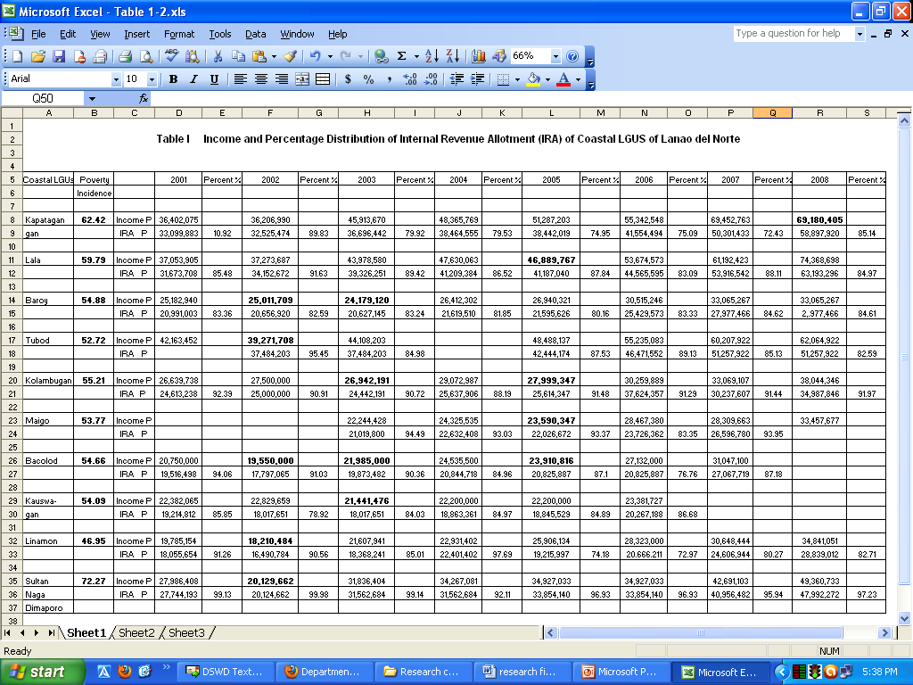

This table portrayed the income and the Internal Revenue Allotment (IRA) of Coastal LGUs. The data indicated that all coastal LGUs derived their revenue primarily from their share of the national income generated by the Bureau of Internal Revenue (BIR), translated into the so-called Internal Revenue Allotment (IRA).

Lala of Lanao del Norte, which had a total income of P74,368,698, had the highest IRA share among Coastal LGUs in the year 2008 amounting to P63,193,296. However, this is only about 84.97% of the total generated revenues of the municipality of Lala in fiscal Year 2008. Compare this with the municipality of Kolambugan, the latter’s IRA share comprised 91.97% of the LGU’s total collection in the same year and only had a total income of P38,044,346. This scenario shows that the local collection of Kolambugan has been less efficient than that of Lala, Lanao del Norte.

The disparity or gap in the revenue collection between the two LGUs specified was attributed to the hindering factors in revenue collection. One of those factors mentioned is the unstable peace and order situation of Kolambugan as revealed in the FGD conducted in Kolambugan last 12 March 2010.

Table I also revealed that the total income of most coastal LGUs have been increasing, although in different percentages. The municipalities of Kapatagan and Lala, for instance, have almost doubled their total income from 2001 to 2008. Kapatagan increased their income from P36,402,075 to P69,180,405 and Lala increased their income from P37,053,905 to P74,368,698. Other municipalities, however, only had a 20M increase or lower. Baroy, for instance, only had an increase of P7,882,327 in the span of seven (7) years from P25,182,940 to P33,065,267. Kauswagan, as well, experienced an increase of only P6,202,275 from 2001 to 2007.

In addition, although, Kapatagan had a poverty incidence of 62.42% in 2003, its revenue collection seemed better than the rest of the coastal LGUs. In the year 2008, its IRA was only 85.14% out of its total income as compared to Sultan Naga Dimaporo where the percentage of IRA to its total income is 97.23%. It implies then that the revenue collection of Kapatagan, Lanao del Norte is better than that of Sultan Naga though both municipalities are among the top 20 poorest municipalities as of 2009. (NSCB Factsheet)

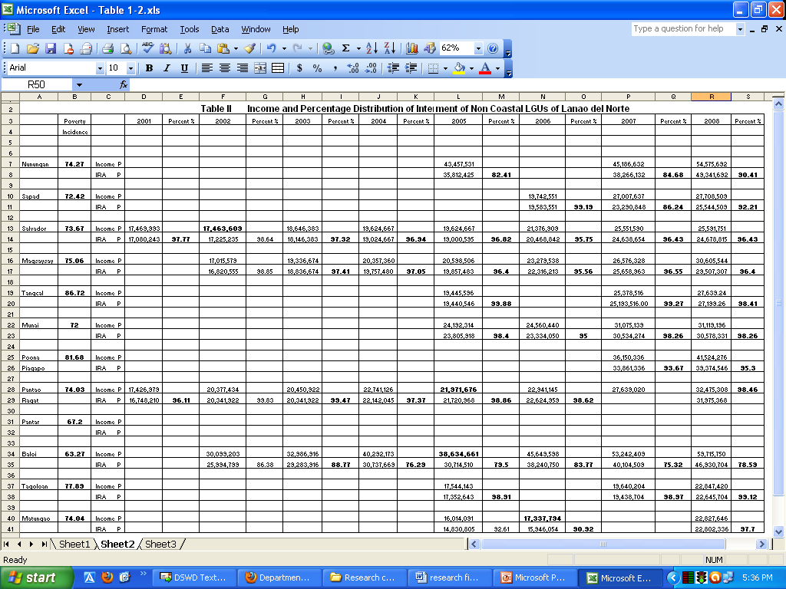
Based on the Small Area Poverty Estimates of 2003, all non-coastal LGUs have been included in the top 20 poorest municipalities of Region X. Table II shows that all non-coastal LGUs were recorded to have poverty incidences of at least 70%, except for only LGUs, Baloi and Pantar with poverty incidences of 63.27% and 72.% respectively. Tangcal, with a poverty incidence of 86.72% was found to be the poorest municipality, not only among all non-coastal LGUs, but among all LGUs in Lanao Del Norte. .

Further, data in this table indicates that all non-coastal LGUS have been heavily dependent on their IRA and have very poor revenue collection mechanisms. Although, incomes have been increasing for every LGU each year, as shown in the table, IRA share of almost all non coastal LGUs (except Baloi) covered 90% of their total income. In the case of Salvador, for instance, its total revenue in the year 2008 was P25,591,751. Its IRA, amounting to P24,678,815, was about 93.43% of the LGU’s total revenue. The municipality, however, with the highest percentage of IRA over its total income is Tagoloan with 99.12%. This is followed closely by the municipalities of Pantao, Munai and Tangkal with at least 98.26%.

Baloi, having the lowest poverty incidence among all non-coastal LGUs, also had the highest income in 2008. Their total income amounted to 59,715,750, which can be attributed to its receipt of shares from National Power, recently known as the National Grid, whose power plants are located there. Its IRA of about P46,930,704 comprises only 78.59% of its total revenue in the year 2008, a small percentage compared to other municipalities. It is an indication, therefore, that Baloi has improved in their local revenue collection as compared to the rest of the non-coastal LGUs. Nunungan, which had the second-highest income among all non-coastal LGUs, had a total income of P54,575,692 in 2008 but 90.41% came from their IRA. Despite this, its poverty incidence remains at 74.27%. The municipality of Poona also has a high 81.68% poverty incidence but it has the third highest total income among all non-coastal LGUs.

As reflected in Table II, no data was acquired from the municipality of Pantar while a lot of information from years 2001-2004 were unavailable for Nunungan, Sapad, Tangkal, Munai, Poona (up to 2006), Tagoloan and Matungao.

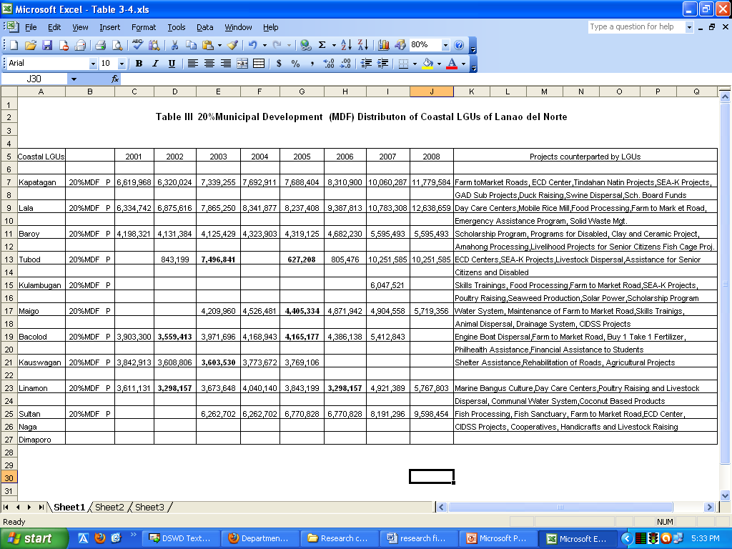

Internal Revenue Allotment (IRA) was basically the share of local government units (LGUs) from the revenues of the national government. It was meant to assist the LGUs in defraying their operational expenses and in delivering basic services. It was even considered as the lifeblood of the LGUs.

The Local Government Code of 1991 provided for the automatic release of IRA and signaled the transfer of delivery of basic services and certain regulatory functions from the national government to the LGUs. According to the law, the LGU share in local taxes collected by the BIR is 40% while the national government got the balance. The Code also mandated each LGU to appropriate in its annual budget no less than 20% of its annual IRA for development projects, called the Municipal Development Fund (MDF), as expressed in their Annual Investment Plan. (Sec. 287, R.A. 7160)

In connection with this mandate, Table III presented the 20% Municipal Development Fund of coastal LGUs of Lanao del Norte. Because the municipalities of Lala and Kapatagan had the highest IRA among all coastal LGUs, they also had the highest amount of MDFs—in the year 2008, Lala had P12,638,659 while Kapatagan had P 11,779.564. Ironically, though, Kapatagan has the second highest poverty incidence among all coastal LGUs of Lanao del Norte at 62% and Lala has the third highest at 59%. The municipality with the lowest poverty incidence at 46%, Linamon, only had a MDF of P 5,767,803.

Despite this situation, these coastal LGUs managed to allocate financial counterparts to national government projects and other funding institutions from their 20% MDF. Among these institutions are the Global Equity for Mindanao (GEM) and the Mindanao Rural Development Program (MRDP). Table III gives a list of all projects funded by non-coastal LGUs of Lanao del Norte giving financial counterparts from their IRA.

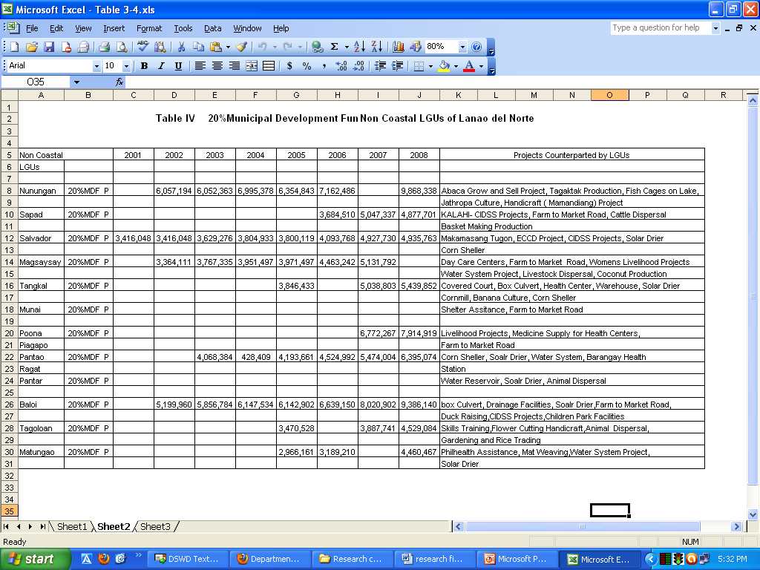

Although non-coastal LGUs of Lanao del Norte has a high poverty incidence, their 20% MDF has increased very minimally over the years. Data in Table IV shows that Nunungan had the highest amount of MDF at P 9,868,338 and almost all other municipalities only had P 4-5M. Despite this, coastal LGUs were able to provide financial counterparts to national government projects as listed in the same table. This includes DSWD projects like SEA-K and CIDDS. However, the municipality of Nunungan still has a high poverty incidence of 74%, the fourth poorest non-coastal LGU in the province. Interestingly, the poorest non-coastal LGU, Tangkal, has a MDF of P 5,439,852, an amount higher than at least four other LGUs.

Nevertheless, conditions of poverty remain visible throughout the years 2001 – 2008 because a) projects were not sustained and b) these non-coastal LGUs are vulnerable to situations of armed conflict. As what respondents in the FGD, one of the major hindrances in the implementation of these special projects was the peace and order situation of the municipalities. (FGD, January-May, 2010)

Appropriations for Programs and Projects Addressing Poverty Issues of LGUs in Lanao del Norte

The absence of fiscal policies in LGUs of Lanao del Norte did not hinder LGUs from implementing projects for the poor as reflected in their investment plans. However, a lot of these projects were considered “special projects”, like Farm to Market Road, Solar Dryers, Water Reservoirs or Water System and Corn Sheller, that required financial counterparts from the LGUs. There is no fixed amount and is dependent on the amount specified in the contract for every project.

Although all LGUs of Lanao del Norte adopted special projects and implemented the same in their locality, whether coastal or non-coastal, there have been no fiscal policies enacted that could serve as basis for budgetary allocation for programs/projects responding to poverty problems of their constituents. It has been the practice for municipal government units to use most of their funds for financial counterparts while programs/projects conceptualized locally still required proposals that are subject to priority projects reflected in their Annual Investment Plans.

In the case of Tubod, the municipal government unit assisted a cooperative by providing seed money drawn from their 20% MDF. The project, however, was not sustained since the beneficiaries found difficulty in paying for their amortization or return of payment. (FGD in Tubod, March 2010). Likewise, the LGU of Bacolod, also extended assistance to its fisher folks by providing pump boats and giving them an affordable and easy plan to pay in return. However, beneficiaries experienced the same difficulty in paying up. This was expressed clearly in the FGD held last 9 March 2010. The failure to pay in return, according to respondents, was due to the insufficient income generated from selling aquatic foods that wasn’t even enough to sustain the needs of the beneficiaries’ families.

The LGU of Magsaysay also had the same problem in the collection of return payments from their SEA-K beneficiaries. Beneficiaries’ primary source of income was agriculture and is always affected by the unstable peace and order condition of the locality. (FGD, 16 March 2010). One can see from these cases that there is a problem of sustainability among poverty programs/projects that are locally conceptualized and locally led. The absence of existing legal document to compel beneficiaries to settle their obligations and for the administration in control to exercise power and authority over the concerned beneficiaries is seen as the primary factor hindering the development of Lanao del Norte as a whole. The locally conceptualized and locally led poverty programs/projects have been proposal-based; appropriations for such programs/projects have, therefore, been flexible and projects are done once they are completed. It opens the possibility for proposals requiring a bigger amount to be turned down even when funds from IRA are available for LGUs to utilize. There was no commitment to sustain or strengthen these efforts leaving poor households stuck in their current situation.

This is the picture of LGUs in Lanao del Norte who sought indebtedness to finance programs/projects for the past years. An amount from their 20% MDF have been drawn to pay for the indebtedness of the LGUs when this should, in fact, be used to create and implement the necessary programs/projects to alleviate poverty. When the IRA increases, the 20% MDF also increases; but the increase has not been translated to improved quality of life.

LGUs Best Practices in Addressing Poverty concerns and Issues

There were no records of fiscal policies in all LGUs of Lanao del Norte throughout the years 2001 to 2008. However, municipalities were able to implement programs and projects addressing poverty in their respective locality. A few LGUs take pride in their ‘best practices’ as measures to address poverty problems of their constituents in the absence of local legislations.

Two LGUs proudly declared that their Day Care Centers are their ‘showcases’ or achievements, that which trademarks the LGU—Kapatagan Day Care Center and the Early Child Development (ECD) DCC of Kolambugan are said to be complete and well-maintained. Kolambugan ECD DCC even has its own resource center where reading materials for children are made available.

Both are also handled by a skilled day care worker. (FGD, March 9, 2010). The sustainability of the Kapatagan DCC was realized due to the Participatory Management approach employed by the Kapatagan LGU. The local executive, for instance, conducts periodic monitoring by holding meetings with key persons involved directly with the project and discussing issues/concerns related to the operation of the center. (FGD, 19 March 2010)

The LGUs of Munai and Kauswagan consider their Access Road Towards the Modified Shelter Project and Access Road to Delabayan Rehabilitation Center, respectively, as their showcase projects. These access roads allowed beneficiaries to easily access economic and social activities to the municipalities concerned. (FGD, 11 March 2010) On the part of municipalities Linamon, Sapad, Magsaysay, Poona Piagapo, Pantao Ragat, Tubod , Matungao and Nunungan, meanwhile, they consider their special projects, funded partially by the LGU, as their best practices. (FGD, 12-22 March & 7 April 2010) Similarly, the LGUs of Baloi and Tagoloan specified that the Baloi-Tagoloan-Talakag Access Road was their primary achievement. It enabled the public to transport their products to the local market. (FGD, 11 March & 21 April 2010)

This practice prompts LGUs to realign their budget and accommodate the advent of Special Projects in their financial appropriations. However, it also reflects the fact that these LGUs are finding it difficult to conceptualize and lead their own projects that is related to the lack of funds or difficulties in revenue collection.

Non-coastal LGUs, for instance, had lesser chances to improve their local collection because of unstable peace conditions. Tubod and Linamon, on the other hand, had no proponents within the local government pushing for poverty programs/projects. (FGD, 12 & 16 March 2010)

The municipality of Tangkal has been a recipient of several projects they consider as showcases. They had bridges, solar dryers and a multi-purpose building installed in their locality. Infrastructure projects like these were many especially since the LGU has earned a track record of finishing projects on time and upholding peace and order while constructions are going on. (FGD, 14 April 2010)

Pantar and Maigo, meanwhile, reiterated that the installation of a water system in their respective municipalities were their ‘showcase practices’. Maigo then enjoyed a source of potable water with the cheapest charge in the area, while constituents of Pantar enjoyed potable water for free. (FGD, 8 & 21 April 2010)

Coastal municipalities like Lala and Baroy mentioned income-generating projects that had been successful to attract investments. Lala takes pride in their Kalamansi Plantation, Alimango and Burnay Culture and Salted Fish Preservation. The municipality is also considered as the rice granary of Lanao del Note given its vast rice fields. In Baroy, meanwhile, the LGU gave financial counterparts to operate the so-called Community Internet Café. (FGD, 14 April 2010).

Some LGUs of Lanao del Norte exerted their own initiative in sustaining the projects which they regarded as their trademarks even without the necessary local legislation that would govern the implementation of these projects. In the case of Kapatagan, for instance, the local chief executive created a committee to monitor the project simultaneous with the national government agency responsible for implementing the project. The committee conducted periodic evaluation for some of their projects.

On the other hand, in Bacolod, the Mayor’s office and MSWDO worked hand-in-hand in project monitoring despite the lack of an allocation from the 20% MDF to sustain the projects. At times, people involved in the monitoring of these projects used their personal funds to complete the task.

The LGUs of Lanao del Norte acknowledged that there would be a need to enact local fiscal policies, with clear and defined guidelines, to minimize problems encountered during the implementation of the project or block any potential programs/projects for the poor.

MSWDO Appropriation and its Utilization

The DSWD is mandated to provide assistance to LGUs, NGOs, other national government agencies (NGAs), peoples’ organizations (POs) and other members of civil society in effectively implementing programs, projects and services that will alleviate poverty and empower disadvantaged individuals, families and communities for an improved quality of life.
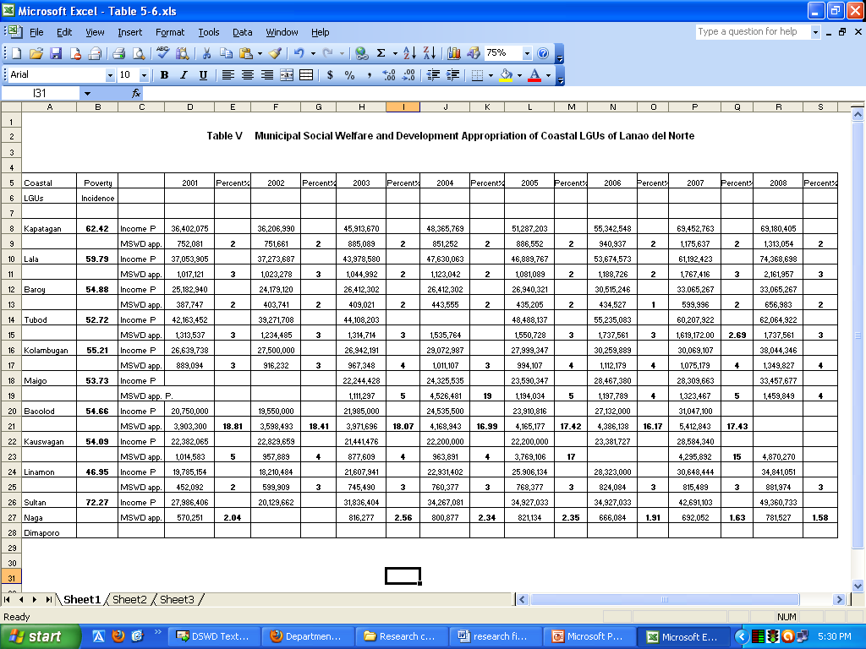

The local government appropriates funds for the said office as reflected in their General Appropriation Fund. Above is a table presenting the LGU appropriation of coastal municipalities for their MSWDOs from fiscal years 2001 to 2008. It shows the MSWDO funds increased yearly but it varies per LGU; for instance, the LGU of Kauswagan experienced an increase from 1,014,583 in 2001 to 4,870,270 in 2008 but their total income only increased minimally from about P 22M in 2001 to about P 28M in 2007. Meanwhile, the municipality of Baroy only increased their MSWDO funds from 387,747 to 656,983 in the span of seven years. This is despite an increase in LGU income from 25,182,940 in 2001 to 33,065,267. Baroy also had the lowest MSWDO funds in 2008 among all coastal LGUs while Lala had the highest allocation in the same year with 2,161,957.

However, among all coastal LGUs, it seems that Bacolod appropriated the highest percentage of its income to its MSWDO. This explains why this LGU is able to monitor on-going projects and deliver better social services to its constituents.

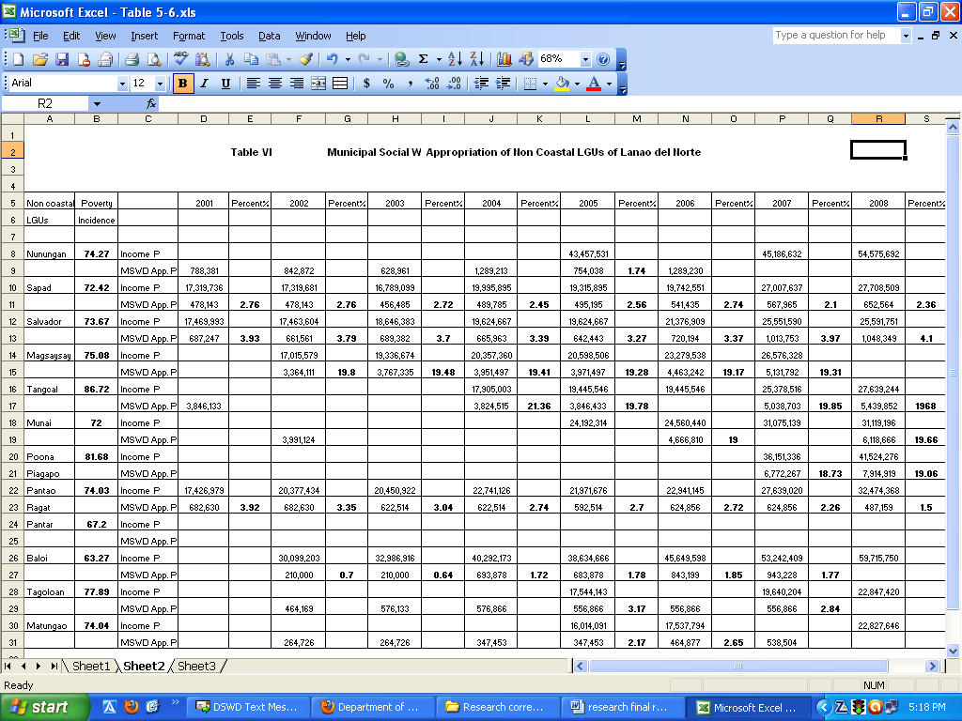

Table VI, on the other hand, portrays the budgetary allocation for MSWDOs among non-coastal LGUs of Lanao del Norte. It shows that funds increased yearly for almost all municipalities albeit very minimally and there was even one municipality, Pantao Ragat, which saw a decrease from P 624,856 in 2007 to P 487,159 in 2008. In addition, this municipality’s fund for their MSWDO in 2001 was pegged at P 682,630, a figure even higher than the allotted funds for 2007. Meanwhile, the MSWDO funds for the municipality of Sapad only increased by P174,421 from P478,143 in 2001 to P652,564 in 2008.

However, in the case of Salvador, the appropriation for the MSWDO in 2001 was only P 687,247 but was increased to as high as P1,048,349 in 2008. The allocation doubled throughout the seven years. Data also shows that municipalities of Magsaysay, Tangcal, Munai and Poona Piagapo had the biggest allocations for their MSWDO. These were, after all, areas often affected by armed conflicts that need funds for the rescue and protection of evacuees and provision of shelter, food and medicine. MSWDOs from these municipalities also had the highest percentage share from their total income.

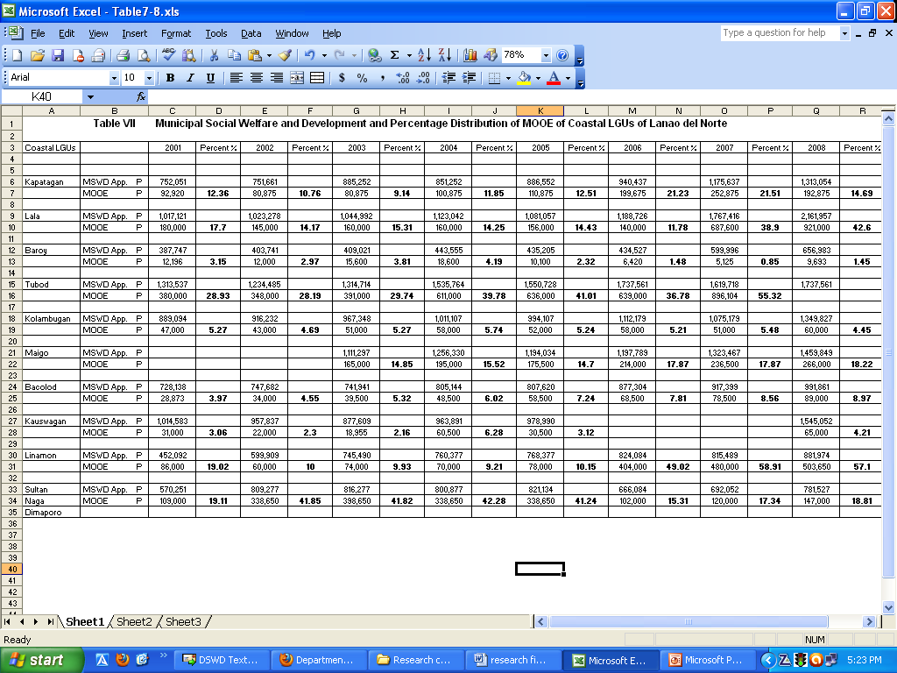
Table VII, showed MSWDO budgetary allocation and percentage distribution of Maintenance and Other Operating Expenses (MOOE) among coastal LGUs in Lanao del Norte. It specified that the highest MOOE appropriation for social services was in the municipality of Lala in 2008 amounting to P 921,000. This is 42.6% of its MSWDO funds. However, in terms of the percentage of MOOE funds to MSWDO funds, Linamon in 2008 had the highest appropriation for its MOOE by allocating 57.1% of its P881,974 MSWDO funds. This translates to MOOE funds of 503,650 for Linamon. For three (3) consecutive years, fiscal years 2006 to 2008, the municipality of Linamon spent at least 49% of their MSWDO funds annually to MOOE. Tubod, on the other hand, comes in close to Linamon by allocating 55.32% of its MSWDO funds to MOOE in 2007 amounting to P 896,104. By quantities, however, Tubod in 2007 had twice the MOOE funds of Linamon.

On the other hand, the LGU of Baroy has the lowest MOOE allocation among all coastal LGUs. For example, in 2008, only 1.45% of its MSWDO funds were allotted for MOOE. This is only P 9,693. The year prior to that, MOOE funds were only .85% of its MSWDO funds; that is only P5,125.

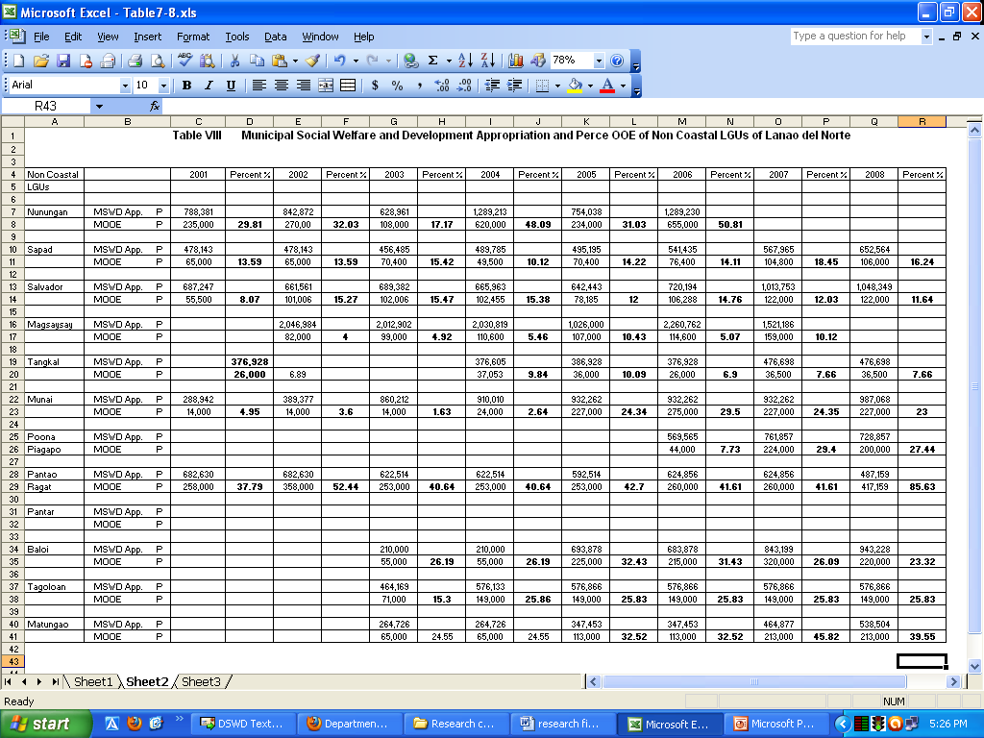

Among all non-coastal LGUs, the only municipality inaccessible to public transport is Nunungan. Besides being far from the nearest municipality, Kapatagan, the roads going there are very poor. This inaccessibility affects the economic and social status of people in Nunungan. For this, their municipal government allocated P1,289,230 for their Social Welfare and Development Office in 2006. From that appropriation, 50.81% or P655,000 was drawn purposely for the Maintenance and Other Operating Expenses (MOOE).

The municipality of Tangkal has both the smallest amount of MOOE and smallest percentage in MOOE appropriation vis-à-vis MSWDO funds. For the year 2008, it only had P 36,500 of MOOE compared to its MSWDO funds of P 476, 698. They had pretty much the same amount of MSWDO fund with the municipality of Pantao Ragat but Pantao Ragat allocated 85.63% of this to MOOE funds. This amounts to P 417,159 that indicates high prioritization in this LGU for social services. Previous to this year, it still had the highest percentage of MOOE fund allocation vis-à-vis MSWDO funds among all non-coastal LGUs with 41.61%. In this year, however, 2007, the biggest MOOE funds belonged to the municipality of Baloi with P 320,000.

In general, however, all non-costal LGUs experienced very minimal increase in MOOE funds over the years. There were even times when the percentage would decrease, such as in Nunungan from 48.09% in 2004 to 31.03% in 2005 and Tangkal where MOOE funds vis-à-vis MSWDO funds dropped from 10.09% to 6.9%. It reflects a lesser degree of prioritization being placed in social services by non-coastal LGUs despite the high degrees of poverty in their areas. The municipality of Tangcal, for instance, which has the highest poverty incidence among all LGUs in Lanao Del Norte with 86.72%, only has a 7.66% MOOE funds vis-à-vis its MSWDO funds, the lowest percentage among all non-coastal LGUs. It also has the lowest funds for its MSWDO. The municipality of Pantao Ragat is commendable, for because of its 74.03% poverty incidence, it chose to allocate P 417,159 from its MSWDO funds in 2008 of P 487,159 to MOOE.

Hindering Factors in Fiscal Policy Formulation in Addressing Poverty Issues and Concerns

Another research question that this study seeks to answer is to identify what the hindering factors are in fiscal policy formulation relative to poverty issues/concerns. Based on the conduct of FGDs in all LGUs of Lanao del Norte, local legislators lacked the capability and expertise to formulate the necessary fiscal policies that would give priority to allocation of poverty programs/projects. It was stressed, for instance, that members of the Sanggunian lacked political maturity and are do not have platforms to reflect their constituents’ needs. In fact, it was found out that most local legislators installed are not aware of their primary function in the local government system. Constituents themselves lack the political awareness that would enable them to pressure local legislators in formulating policies for poverty alleviation. (FGD, 8 March 2010)

Table IX

LGUs | Unca-  pable Legis-  lators | Unsta-  ble  Peace  & order | Lack of peoples  Aware-  ness | Mgt.  Prob-lem | Lack of monito-  ring &  Team-  work | Limi-  ted  Fund-  ing | No  Elec-  tricity | Poor  Access  road | No  existing  records
Nunungan  Pantaoragat  Poonapiagapo  Munai  Tangkal  Magsayasay  Salvador  Sapad  Matungao  Tagoloan  Pantar  Baloi  SND  Kapatagan  Lala  Baroy  Tubod  Kolambugan  Maigo  Bacolod  Kauswagan  Linamon | x  x  x  x  x  x  x  x  x  x  x  x  x  x  x  x  x  x  x  x  x  x | x  x  x  x  x  x  x  x  x  x  x  x  x  x  x  x  x  x | x  x  x  x  x  x  x  x  x  x  x  x  x  x  x  x  x  x  x  x | x  x  x  x  x  x  x  x  x  x  x  x | x  x  x  x  x  x  x  x  x  x  x  x  x  x  x  x  x  x | x  x  x  x  x  x  x  x  x  x  x  x  x  x  x  x  x  x  x  x  x  x |  | x  x  x  x  x | x

The table above presents the common hindering factors experienced by LGUs in Lanao del Norte. All LGUs are shown to have problems in the competence of local legislators to formulate fiscal policies at their level and are not even aware of their legislative functions. This leads to insensitivity to the demands of the people. Limited local funds was also mentioned as another major factor that relates to why there are no fiscal policies conceptualized; some local legislators say that didn’t bother to push for these guidelines. Moreover, constituents, in general, lack awareness in their right and power to participate in activities to alleviate poverty or push the local government to do so.

Other factors mentioned that hinder the formulation of fiscal policies are the lack of monitoring mechanisms and the unstable peach and order that affects project administration in the localities.

Problems Encountered by the municipal government implementers of projects addressing poverty issues and concerns

1. Identification of the project beneficiaries were politically motivated as in the case of Kauswagan, Lanao del Norte. Beneficiaries became dependent on the government’s grants without being required to have a counterpart of their own. They saw the LGU as a ‘provider’ without any accountability in any form.

2. Failure to pay in return was seen as a prominent problem in the cases of Bacolod and Tubod despite an affordable and easy paying plan.

3. In the case of Nunungan, the major problem mentioned was the very poor access road from the municipality of Kapatagan. People, for one, experienced difficulties in transporting their products for sale to neighboring municipalities. Nunungan also has no electricity affecting the implementation of some projects in the locality.

4. Peace and order is seen as one of the problems encountered by implementers especially in the case of non-coastal LGUs like Kauswagan, Kolambugan, Maigo and Bacolod. This delays project completion and affects the economic activity of the people residing and transacting in those areas.

Technical Assistance and Resource Augmentation Needed by LGUs of
Lanao del Norte

Based on a series of FGDs with al LGUs of Lanao del Norte, the following areas were identified as LGUs’ weaknesses in terms of projects for poverty alleviation. They strongly suggested that these areas be given attention by national agencies particularly the Department of Social Welfare and Development (DSWD).

Areas for Technical Assistance(TA) | Type of Technical Assistance(TA) | Objectives | Remarks
Capability Building | Training- workshop for legislators both at the municipal and barangay level (in-house) | To equip legislators in terms of techniques to formulate policies and enable them to be aware, not only of their legislative functions in the local government, but also in being sensitive to the needs of their constituents | DSWD needs to coordinate with the Department of Interior and Local Government (DILG) in the conduct of the said training- workshop. DSWD should also strengthen its advocacies in enacting national legislations on the ground level
Capability Building | Enhancement Trainings for Implementers | To provide updates regarding new approaches and techniques that will update the fiscal policies governing the implementation of poverty programs and projects. | DSWD needs to coordinate with MSWDOs more closely and monitor their performance especially in terms of their attendance and commitment to their tasks and responsibilities
Capability Building | Advocacy Training for beneficiaries | For beneficiaries to be aware that the projects undertaken are for their own benefit, in the short-term and in the long run, and that they are the end-users of the project. | DSWD should coordinate with the local executive and the MSWDO in the advocacy that beneficiaries were integral component for the success of the project
Resource Augmentation | Additional funding for programs and projects addressing address poverty issues/concerns. | All LGUs in Lanao del Norte financed their poverty programs/projects from the 20% Development Fund since they do not have enough mechanisms to collect revenue. These seem to be insufficient for municipalities experiencing very high poverty incidence that are plagued further by other concerns (i.e. armed conflict and poor access roads).

IV. Summary of Findings, Conclusion and Recommendations

The preceding subsections presented the findings of the investigation designed to provide a comprehensive evaluation of LGUs’ fiscal policies and practices addressing poverty concerns of their constituents. Salamon and Wamsley’s theoretical framework was used featuring the following criteria: policy timing, policy substance or character and policy administration.

Policy timing in this study was investigated as to whether there was a sense of urgency in the part of the local government to conceptualize local fiscal policies addressing poverty. The NSCB Factsheet of May 26, 2009 indicates that several LGUs of Lanao del Norte are among the top 20 poorest LGUs of Region X. At the same time, there are already existing legislations at the national level (i.e. Social Reform and Poverty Act of 1998) that could serve as basis for enacting local legislations among LGUs in Lanao del Norte. Provisions from the Local Government Code of 1991 also mandate LGUs to support development program and projects using their IRA allotment.

However, after a thorough documentary review of local records and conduct of FGDs with key personnel from the LGUs, all municipal governments of Lanao del Norte do not have existing local fiscal policies or ordinances to govern the necessary appropriation for poverty programs/projects. There is, therefore, no legal basis to automatically allocate funds for LGU-led activities that often leads to sustainability issues and failure to produce significant results. Despite the crafting of annual investment plans, in consonance with development goals and targets of LGUs, those policies are still necessary to implement and actualize the plans.

Their initiatives in poverty alleviation, therefore, were dependent on special projects launched by the national government or by NGOs (i.e. Growth Equity of Mindanao, Mindanao Rural Development). For fiscal years 2001 to 2008, they have been providing material, technical and financial counterpart to these special projects. Very few projects were led and conceptualized by the LGUs themselves and are mostly livelihood in nature. The municipality of Bacolod had a Pump Boat Dispersal project for the fisherfolk sector of their locality while Tubod extended financial assistance as Seed Money to their local cooperative. Alas, these projects were not sustained due to problems in return payment of the beneficiaries.
Policy substance or character, meanwhile, is evaluated by the consistency of the budget allocation to the municipal development plans. With the absence of local fiscal policy, LGUs have no specific guidelines in terms of appropriating funds for programs and projects addressing poverty. Meanwhile, looking at financial appropriations for the MSWDO and its corresponding MOOE funds, it looks very minimal compared to the constituents’ needs. Going back to Tables V and VI, most LGUs in Lanao del Norte allocated only about 1% – 4 % of their income for the MSWDOs. Unfortunately, this applies even to municipalities with very high poverty incidence like Tagoloan (77.89%), Nunungan (74.27%), Salvador (73.67%), Sapad (72.42%), Sultan Naga Dimaporo (72.27%) and Baloi (63.27%). Among non-coastal LGUs, only Magsaysay, Tangcal and Poona Piagapo were able to allocate 18% – 19% of their income for their MSWDOs. Among coastal LGUs, meanwhile, only Bacolod and Kauswagan were able to allocate at least 15% of their income for MSWDO funds.

Policy administration deals with how the project was undertaken by the LGUs of Lanao del Norte. It also includes an evaluation of how activities were planned and scheduled and how well it was implemented to fit the beneficaries’ needs and concerns. In terms of special projects implemented in coordination with NGAs and NGOs, the role of LGUs are limited to providing financial counterpart in terms of material and technical resources as required in the agreement. Monitoring and management was not of their concern and these projects are, therefore, likely to be completed on time and to be sustainable.
Some LGUs though, like Tangkal, assisted in ensuring the success of a special project by upholding peace and order in the locality. It was then able to safeguard the implementers of the project.

For locally-led projects, however, livelihood projects failed due to the inability of beneficiaries to give their return payments. It reflects a management lapse on the part of the LGUs Bacolod and Tubod which conceptualized the project.

The idea is commendable for these are only two of very few locally-led projects in the province but policy administration failed miserably and municipalities remain poor. There were also no sanctions placed on those who fail to pay in return leaving beneficiaries no incentive to push themselves towards sustaining the project.

In general, while there are no existing fiscal policies among LGUs of Lanao del Norte, some were still able to implement programs/projects for the poor from partnering with the government and NGOs or initiating their own. However, because most poverty programs/projects are deemed ‘special projects’ through a contract with their partners, LGUs become very dependent on their partners’ ideas or financial resources. Most development projects were funded from the 20% Municipal Development Fund of the IRA and spending was patterned according to project proposals made by the LGUs. Moreover, throughout the years, funds for the MSWDO to provide constituents with the necessary social services remain low relative to the municipality’s total income and poverty incidence rates.

The existence of local policies should be able to encourage LGUs in conceptualize projects of their own that is customized according to their constituents’ exact needs. It will also place greater emphasis on the need to allocate a sufficient budget to implement these projects efficiently.

Results of the FGDs also revealed suggestions on how the Department can strengthen their technical assistance and resource augmentation functions to help local governments more effectively. These are the following:

- There is a need to conduct capability-building trainings/workshops for legislators, implementers and beneficiaries of the project in the LGUs of Lanao del Norte. Capability trainings/workshops should be given to legislators at both the municipality and barangay levels and conducted within the LGUs they are representing. The conduct of enhancement trainings for implementers was also recommended. Implementers need to be updated with new approaches and techniques for handling projects and with regard to fiscal policies governing the implementation of projects. Advocacy training and character build-up for beneficiaries are also necessary for them to be aware that they are part of the project as end-users and that they are accountable to the success and sustainability of the program.

- It is recommended that those who have control over locally-conceptualized and locally-led projects, particularly in supervision and management, be trained properly and be given no other task than that. They should be able to focus on that project and not be placed on top of their regular work load. A new employee should be hired to handle this specific task.

- There are some LGUs in Lanao del Norte where the peace and order situation is unstable; even LGUs fail to take full control. In this connection, there is a need for police forces to be assigned in these areas to better regulate the violence especially when necessary. Not only does the violence hinder business activities and, ultimately, economic progress in the area, it also restrains the implementation of development projects.

- The municipality of Tangkal is considered the central municipality of Lanao del Norte. It has access to non-coastal LGUs and is often affected when lawless elements attempt to destabilize the province. Many evacuees flock to their municipality when neighboring LGUs are experiencing armed conflict. It is recommended, therefore, that an evacuation center be constructed in Tangkal to safeguard the evacuees.

- Aside from training-workshops to be conducted for legislators, there is a need for the DILG and other institutions to install a mechanism that will closely monitor and assess the performance of legislators in their respective LGUs, both in the municipal and barangay levels.

- There is also a need to define the organizational structure of LGUs in Lanao del Norte so there will not be an overlapping of functions and accountability of each will be easily identified.

- Create and develop linkages to market their products.

- All LGUs of Lanao del Norte need additional financial augmentation and proper orientation from DSWD to uphold the sustainability of LGU-led projects and in expression of the national government’s support to LGUs.

- DSWD should coordinate with DILG and other institutions regarding the capability-building of legislators, to equip them with the skills in formulating policies which are necessary in the LGUs to address poverty problems of the constituents.

- LGUs of Lanao del Norte need the DSWD to advocate national laws and policies that will guide the local governments in their implementation. Simultaneously, the DSWD should continue to provide technical assistance in establishing local ordinances that will govern the standards of social welfare assistance to clients.

REFERENCES

Books:

Bautista, Victoria et al. Introduction to Public Administration in the Philippines:
A Reader, Quezon City: college of Public administration, University
of the Philippines, 1993.

Dunn, William. Public Policy Analysis. New Jersey: Prentice Hall, 1991.

Dye, Thomas. Public Analysis, What Governments Do, Why They Do It and
What Difference It Makes, Alabama: The University of Alabama Press, 1976.

Koenig, Louis. Introduction to Public Policy, Englewood Cliffs, Nrew Jersey:
Prentice Hall, 1986.

Lambonao, Leonardo. Government Accounting in Business Education, Metro
Manila: National Book Store, 1987.

Leveriza, Jose P. Public Administration: The Business of Government,
Manila: National book Store, 1983.

Machal, Catherine et al. Designing Qualitative Research, 3rd Edition, London:
Sage Publishing, 1999.

Nolledo, Jose. The 1991 Local Government Code With Basic Features,
Manila: National Book Store,1994.

Prudhomme, A. The Dangers of Decentralization, 1995.

Salamon, Lester and Wamsley, Gary. The Politics of Urban Land Policy:
Zoning And Urban Development in Nashville in James Blumstein et al,
Growing Metropolis, Tennessee Vanderbilt : University Press, 1975.

Veloso, Socorro P.(ed.) Training Module on Integrated Population and Devt.
Planning, Philippines:NEDA-IPDP,1993.

Journals:

De la Cruz, Teofila E. The” Zero Base Budget Concept and Its Application to the City Government Progress” Development Administration Journal, Vol.1, 1981.

Heclo, Hugh. ”Public Analysis”, British Journal of Political Science,Vol. II, No.1, January,1972.

“Notes On Poverty”. Today’s Asian Business Strategy Ezine, Columns, Pearl
of The Orient Sea, 2002.

NSCB Factsheets, RD-10 FS#1,Series of 2009, May 26,2009.

Situationer on social Welfare and Development, Northern Mindanao, Region
X, 2008.

Public Documents:

RA No. 8425 ( Social Reform and Poverty Alleviation Act of 1998).

RA No. 7160 ( Local Government Code of 1991).

Administrative Order No. 2003-82 ( Setting Standards on Social Welfare and
Development Service Delivery System in the Local Government Units)

Memorandum Circular No. 96 – 263 ( Providing Policies and Guidelines on
The Utilization of the 20% Development fund and Related Matters)

General fund Budgets of LGUs in Lanao del Norte, 2001 -2008.

The 20% Municipal Development Fund of LGUs in Lanao del Norte, 2001 2008.

The Annual Investment Plans of LGUs in Lanao del Norte, 2001-2008.

Focus Group Discussions (FGD) conducted in the LGUs of Lanao del Norte,
March 9,11,12,16,17,18,19,22,23, April 7,8,13,14,21 0f 2010.

Unpublished Masters’ Thesis:

Dingal, Teofreda B. and Endriga, Efren. Effects of Budgetary Policies on
Resettlement Program : Case of Iligan City, 1999.

Appendix I

Focus Group Discussion (FGD) Guide Questions For Objectives 4, 5 and 7.

- Does your LGU attempts to address poverty concerns of your constituents? Please identify them.

- What are the bases in conceptualizing those programs and projects?

- Would you consider the implementation of these programs and projects responsive to the needs of the constituents? Can you consider these means as your best practice in addressing poverty concerns?

- Before embarking the poverty alleviation program, does your LGU adopts ordinances, Resolutions, and laws ahead of time which serve as guidelines, rules and regulations for implementation?

- How far have your LGU implemented the poverty alleviation program?

- What are the problems encountered in the formulation of policies as well as in the implementation of the projects?

- How important do you think is DSWD is role in providing assistance and resource augmentation (TARA) to your LGUs?

- What kind of assistance do you need from DSWD in the preparation of budget for Social Welfare and Development and poverty projects?

Figure II - Map of Lanao del Norte

